
4th Annual Monticello Baseball Summer Camp
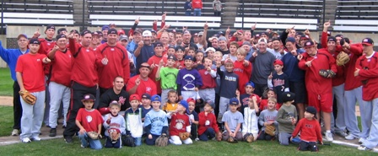

Who: Baseball & Softball Players ages 6-14
What: An Instructional & FUN Baseball Camp
With the SCSU Husky Baseball Staff and players
When: Wednesday, June 11
Time: 10:00am – 3:00pm with a baseball lunch provided
Where: Monticello City Baseball Fields
Cost: $100 per player; 2nd child in family $50
($25 deposit to hold your spot! You Still need to register online)

For more info contact: Pat Dolan at 320-333-3336 Pat@StarzBaseballCamp.com
www.StarzBaseballCamp.com

Come join us in some baseball fun and learn to play the game the right way!
BASEBALL DRILLZ, DRILLZ, DRILLZ to improve BASEBALL SKILLZ with the Starz!

