
7th Annual Chaska Youth Baseball Summer Camp
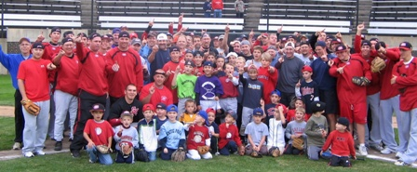

Who: Baseball & Softball Players ages 6-14
What: An Instructional & FUN Baseball Camp
With the SCSU Husky Baseball Staff and players
When: Thursday, June 12th
Time: 10:00am – 3:00pm with a baseball lunch provided
Where: Chaska Community baseball fields, Chaska, MN

Cost: $$100 per player; 2nd child in family $50
($25 to hold your spot! You Still need to register online)

For more inf contact: Pat Dolan at 320-333-3336 or Pat@StarzBaseballCamp.com
www.StarzBaseballCamp.com

Come join us in some baseball fun and learn to play the game the right way!
BASEBALL DRILLZ, DRILLZ, DRILLZ to improve BASEBALL SKILLZ with the Starz!
Who is going to be the next Chaska player to Huskyland?

