
10th Annual Waite Park Youth Baseball Summer Camp
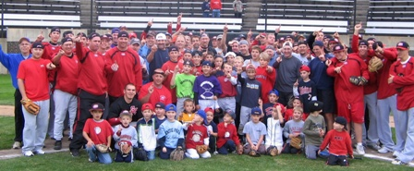

Who: Baseball Players ages 6-13
What: An Instructional Baseball Camp 10-2pm with a game @ 2pm!
With the SCSU Baseball Staff Lead by Head Coach, Pat Dolan
When: Monday, June 10
Time: 10:00am–3:00 with a baseball lunch, camp t-shirt & awards!
Where: River’s Edge Baseball Complex, Waite Park, MN
Cost: $100 (2nd child in family $50)
Or SAVE $25 with cash payment the day of! You Still need to register online
For more info contact: Pat Dolan @ 320-333-3336 Pat@StarzBaseballCamp.com
www.StarzBaseballCamp.com

Come join us in some baseball fun and learn to play the game the right way!
BASEBALL DRILLZ, DRILLZ, DRILLZ to improve BASEBALL SKILLZ w/ the Starz!



