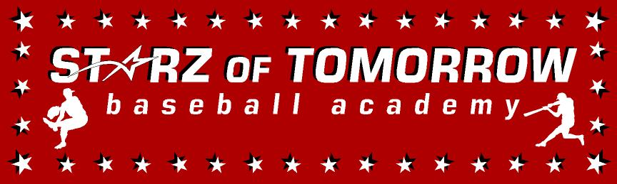
10th Annual Sauk Rapids Youth Baseball Summer Camp
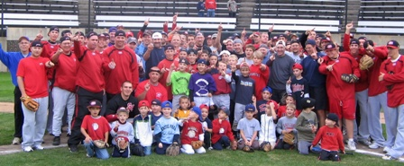

Who: Baseball Players ages 6-13
What: An Instructional Baseball Camp
With the SCSU Husky Baseball Staff and players
When: Monday, June 3rd
Time: 9:00am – 2:00pm with lunch provided
Where: Bob Cross Park, Sauk Rapids, MN

Cost: $100 per player; 2nd child in family $50
Or SAVE $25 with cash payment the day of! You Still need to register online

For more info contact: Pat Dolan at 320-333-3336 Pat@StarzBaseballCamp.com
www.StarzBaseballCamp.com

Come join us in some baseball fun and learn to play the game the right way!
BASEBALL DRILLZ, DRILLZ, DRILLZ to improve BASEBALL SKILLZ with the Starz!

