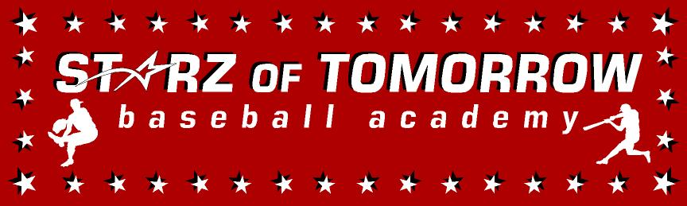
2024 New Ulm Baseball Summer Camp
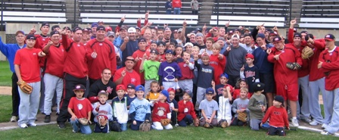

Who: Baseball Players ages 6-13
What: An Instructional Baseball Camp
With the SCSU Husky Baseball Staff and players
When: Tuesday & Wednesday, June 4-5
Time: 10:00am – 3:00pm with baseball lunch provided
Where: North Park, New Ulm
Cost: $100 NUJBA Members/$150 non Members
(or SAVE $25 with cash payment the day of!)
For more info contact: Pat Dolan at 320-333-3336 or Pat@StarzBaseballCamp.com
www.StarzBaseballCamp.com

Come join us in some baseball fun and learn to play the game the right way!
BASEBALL DRILLZ, DRILLZ, DRILLZ to improve BASEBALL SKILLZ with the Starz!
Who is going to be the next Judd Davis, Zach Hoffman, Kyle or Garrett Fischer to Huskyland?

