
Waite Park Youth Baseball Summer Camp
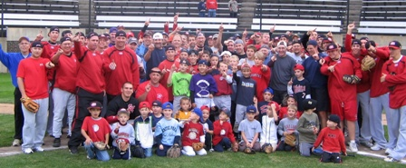

Who: Baseball & Softball Players ages 6-13
What: An Instructional Baseball Camp 10-2pm with a game @ 2pm!
With the SCSU Baseball Staff Lead by Head Coach, Pat Dolan
When: Thursday, June 8
Time: 10:00am–3:00 with a baseball lunch, camp t-shirt & awards!
Where: River’s Edge Baseball Complex, Waite Park, MN
Cost: $75 (2nd child in family $50)

For more information contact: Pat Dolan at 320-333-3336 www.StarzBaseballCamp.com
Come join us in some baseball fun and learn to play the game the right way!
BASEBALL DRILLZ, DRILLZ, DRILLZ to improve BASEBALL SKILLZ w/ the Starz!
Sandlot games each day at 2:00pm for parents to come watch!



