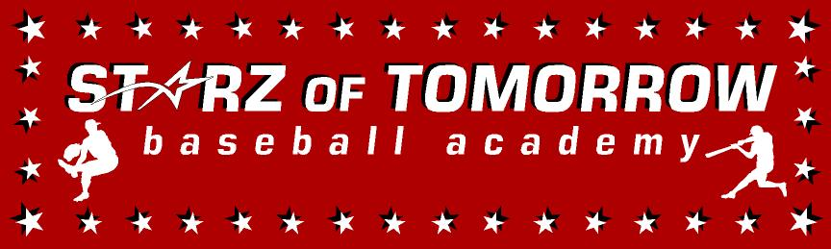
7th Annual Sauk Rapids Youth Baseball Summer Camp
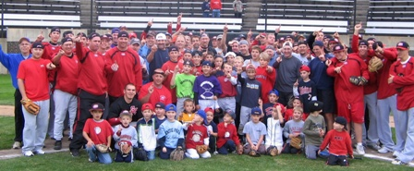

Who: Baseball & Softball Players ages 6-13
What: An Instructional Baseball Camp
With the SCSU Husky Baseball Staff and players
When: Tuesday, June 6
Time: 10:00am – 3:00pm with a baseball lunch provided
Where: Bob Cross Baseball Complex, Sauk Rapids, MN
Cost: $75 per player; 2nd child in family $50

For more information contact: Pat Dolan at 320-333-3336 www.StarzBaseballCamp.com

Come join us in some baseball fun and learn to play the game the right way!
BASEBALL DRILLZ, DRILLZ, DRILLZ to improve BASEBALL SKILLZ with the Starz!

