

Starz of Tomorrow Baseball Academy
2023 Maple Lake Youth Baseball Camp
Monday, June 12th 10:00am-3:00pm
Baseball & softball players 6-13 years old
10:00am-2:00 Skills Camp & GAME from 2:00-3:00pm!
Baseball Lunch, camp T-shirt & awards!
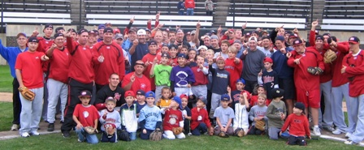
Directed by SCSU Head Coach, Pat Dolan, the 2015 and 2016 NCBWA Central Region Coach of the Year and 2016 National Coach of the Year and his staff!
Location: Maple Lake, MN “Diamond and Dreams” Fields
Register On line at: www.StarzBaseballCamp.com
Or mail this form with payment to Starz of Tomorrow:
PO Box 2063, St. Cloud, MN 56302
Pat Dolan320-333-3336

REGISTRATION Deadline June 1, 2022
Registration: __$75 2nd Child in Family: __ $50
Skills Camps Features:
• Instruction on throwing, fielding, hitting, pitching, base running and more! Drillz &, Drillz to improve Baseball SKILLZ!
• Individual position practice, emphasis on skill development
• Lunch provided
- Camp T-shirt & participation award and Camper of the Day, Charlie. Hustle, Mr. Defense and MVP awards for each group
- Skill Testing in the 60 yard dash, home-to-1st base, position work, on field batting practice, radar gun speed and exit velo
- NEW!! Rapsodo providing base metrics for hitters and position players (spin rate, launch angle, exit velo, x & y axis for pitches, run value, etc.).

Registration Information:
Participant’s name: ______________________________________________________________

Position #1 ___ #2____Ht _____Wt ____Bat ___Throw __
Family Address _________________________________________City _____________ Zip ___
Daytime Phone _______________E-Mail (please print clearly!)_______________________________
Medical Information
Doctor__________________________________Phone_________________________________
Insurance coverage________________________________________________________
Statement of Release: I agree to release the Starz of Tomorrow Baseball Academy and all their employees of all liability related to accidents or injuries which may occur while participating in the above activity. I also give permission for emergency medical procedures to be administered if I cannot be contacted in case of an emergency.
Parent/Guardian signature __________________________________Date________________________________________________



