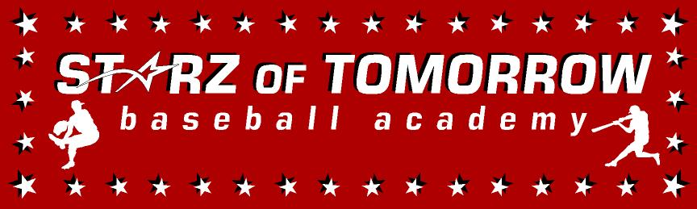
4th Annual Holdingford/Opole/St. Wendel Youth Baseball Summer Camp
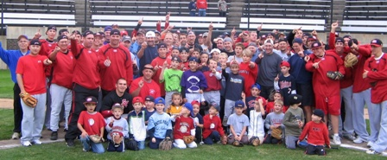

Who: Baseball & Softball Players ages 6-13
What: An Instructional Baseball Camp with a game @ 2pm each day!
With the SCSU Baseball Staff Lead by Head Coach, Pat Dolan
When: Monday & Tuesday, June 19- 20th
Time: 10:00am–3:00 with baseball lunch & camp t-shirt & camp awards
Where: Opole Baseball Field, Opole, MN
Cost: $125 (2nd child in family ½ price)

For more information contact: Pat Dolan at 320-333-3336 www.StarzBaseballCamp.com
Come join us in some baseball fun and learn to play the game the right way!
BASEBALL DRILLZ, DRILLZ, DRILLZ to improve BASEBALL SKILLZ w/ the Starz!
Sandlot games each day at 2:00pm for parents to come watch!

