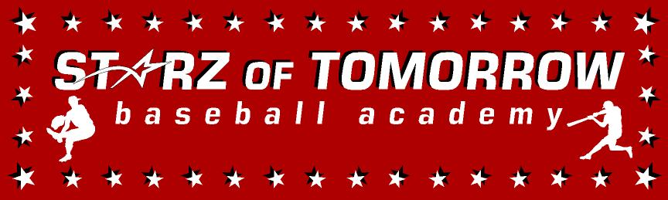
New Ulm Baseball Summer Camp
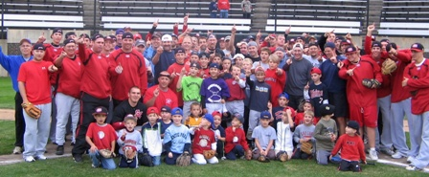

Who: Baseball Players ages 6-13
What: An Instructional Baseball Camp
With the SCSU Husky Baseball Staff and players
When: Thursday and Friday, June 2-3rd
Time: 10:00am – 3:00pm with lunch provided
Where: North Park, New Ulm
Cost: $60 NUJBA Members/$100 non Members

For more information contact: Pat Dolan at 320-333-3336 www.StarzBaseballCamp.com

Come join us in some baseball fun and learn to play the game the right way!
BASEBALL DRILLZ, DRILLZ, DRILLZ to improve BASEBALL SKILLZ with the Starz!
Who is going to be the next Judd Davis, Zach Hoffman, Kyle or Garrett Fischer to Huskyland?

