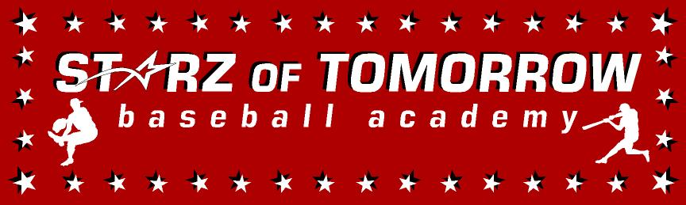
8th Annual Elrosa Baseball Summer Camp
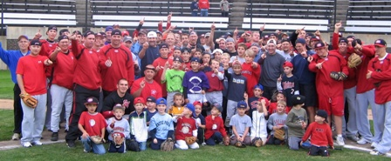

Who: Baseball Players ages 6-13
What: An Instructional Baseball Camp
With the SCSU Husky Baseball Staff and players
When: Friday, June 24th
Time: 10:00am – 3:00pm with lunch provided
Where: Elrosa Saints Baseball Field, Elrosa, MN

Cost: $50 for BBE Players; $75 per player non BBE
2nd child in family $50

For more information contact: Pat Dolan at 320-333-3336 www.StarzBaseballCamp.com

Come join us in some baseball fun and learn to play the game the right way!
BASEBALL DRILLZ, DRILLZ, DRILLZ to improve BASEBALL SKILLZ with the Starz!

