
Central Minnesota WEEK ELITE Baseball Summer Camp
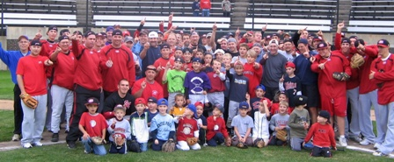

Who: Baseball Players ages 6-13, boys and girls
What: An Instructional Baseball Camp With the SCSU Husky Baseball Staff and players
When: Tuesday, June 7 through Friday, June 10th
Time: 10:00am – 3:00pm with lunch provided
Where: Waite Park-River’s Edge, Sartell-Pinecone, St. Cloud-Whitney & Bob Cross Park, Sauk Rapids,
Cost: Individual: $250 commuter/$350 overnight
Team rate: $200 commuter/$300 overnight
Second player in family ½ price!

For more information contact: Pat Dolan at 320-333-3336 www.StarzBaseballCamp.com
Come join us in some baseball fun and learn to play the game the right way!
BASEBALL DRILLZ, DRILLZ, DRILLZ to improve BASEBALL SKILLZ with the Starz!
Who is going to be the next Judd Davis, Zach Hoffman, Kyle or Garrett Fischer to Huskyland?



