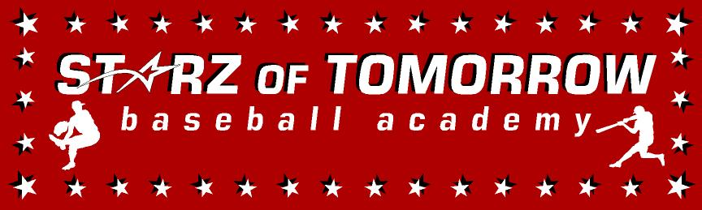
2022 Starz WEEK ELITE Camp
Tuesday-Friday, June 7-10, 13 & younger!
(Overnight & Commuter options from 10:00-3:00pm & SPECIAL Team Rates!)
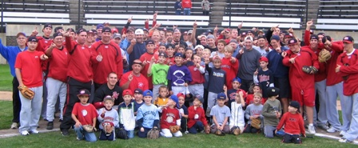
Directed by SCSU Coach, Pat Dolan, 2016 National Coach of the Year & his staff!
Over 75 Central Minnesota players have played for SCSU since 2008! R U NEXT?
Location: Waite Park, Sartell, Sauk Rapids & St. Cloud, Tuesday—Friday (River’s Edge, Pinecone Park, Bob Cross Park & Whitney Fields)
Register On line at: www.StarzBaseballCamp.com
Or mail this form with payment to Starz of Tomorrow:
PO Box 2063, St. Cloud, MN 56302
Pat Dolan 320-333-3336

REGISTRATION Deadline June 1, 2021
Registration: __$250 commuter camper ___$350 overnight camper
TEAM Registration: ___$200 commuter ___$300 overnight campers
2nd Child in Family: __ ½ price
Skills Camps Features:
• Instruction on throwing, fielding, hitting, pitching, base running and more! Drillz &, Drillz to improve Baseball SKILLZ!
• Individual position practice, emphasis on skill development
• Lunch provided for commuters, breakfast, lunch and dinner for overnight campers at the the Granstay Suites
- Camp T-shirt & participation award and Camper of the Day, Charlie. Hustle, Mr. Defense and MVP awards for each group
- Skill Testing in the 60 yard dash, home-to-1st base, position work, on field batting practice, radar gun speed and exit velo
- Overnight fun w/ pool party, pizza party, Baseball movie night, Baseball trivia, Baseball “Chalk Talks” & MORE BB
- SPECIAL TEAM RATE of only $200 for commuter and $300 for overnight with 5+ players from the same team

Registration Information:
Participant’s name: ______________________________________________________________

Position #1 ___ #2____Ht _____Wt ____Bat ___Throw __
Family Address _________________________________________City _____________ Zip ___
Daytime Phone _______________E-Mail (please print clearly!)_______________________________
Medical Information
Doctor__________________________________Phone_________________________________
Insurance coverage________________________________________________________
Statement of Release: I agree to release the Starz of Tomorrow Baseball Academy and all their employees of all liability related to accidents or injuries which may occur while participating in the above activity. I also give permission for emergency medical procedures to be administered if I cannot be contacted in case of an emergency.
Parent/Guardian signature __________________________________Date________________________________________________

