
4th Annual Alexandria Baseball Summer Camp
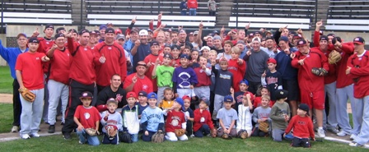

Who: Baseball Players ages 6-13
What: An Instructional Baseball Camp
With the SCSU Husky Baseball Staff and players
When: Wednesday, June 22nd
Time: 9:00am – 2:00pm with lunch provided
Where: Knute Nelson Park, Alexandria, MN
Cost: $75 per player; 2nd child in family $50

For more information contact: Pat Dolan at 320-333-3336 www.StarzBaseballCamp.com

Come join us in some baseball fun and learn to play the game the right way!
BASEBALL DRILLZ, DRILLZ, DRILLZ to improve BASEBALL SKILLZ with the Starz!
Who is going to be the next Judd Davis, Zach Hoffman, Kyle or Garrett Fischer to Huskyland?

