
Richmond Baseball Summer Camp
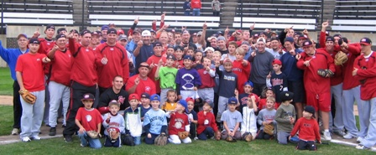

Who: Baseball Players ages 6-13
What: An Instructional Baseball Camp
With the SCSU Husky Baseball Staff and players
When: Saturday, July 10 after the Richmond vs. Farming
Time: 2:30-6:00pm
Where: Richmond Royal Field, Richmond, MN
Cost: $50 per player;

For more information contact: Pat Dolan at 320-333-3336 www.StarzBaseballCamp.com

Come join us in some baseball fun and learn to play the game the right way!
BASEBALL DRILLZ, DRILLZ, DRILLZ to improve BASEBALL SKILLZ with the Starz!
Who is going to be the next Judd Davis, Zach Hoffman, Kyle or Garrett Fischer to Huskyland?

