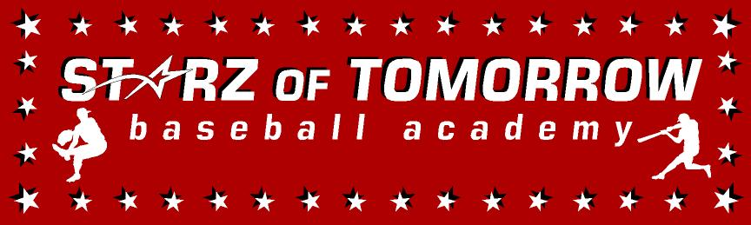
Holdingford/Opole/St. Wendel Youth Baseball Summer Camp
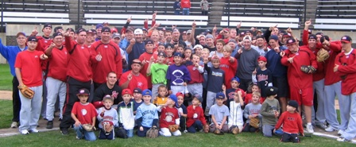

Who: Baseball Players ages 6-13
What: An Instructional Baseball Camp with a game @ 2pm!
With the SCSU Baseball Staff Lead by Head Coach, Pat Dolan
When: Monday, June 21st
Time: 10:00am–3:00 with lunch & camp t-shirt & camp award provided
Where: Opole Baseball Field, Opole, MN
Cost: $75 (2nd child in family $50)

For more information contact: Pat Dolan at 320-333-3336 www.StarzBaseballCamp.com
Come join us in some baseball fun and learn to play the game the right way!
BASEBALL DRILLZ, DRILLZ, DRILLZ to improve BASEBALL SKILLZ w/ the Starz!
Sandlot games each day at 2:00pm for parents to come watch!

