

Starz of Tomorrow Baseball Academy
2021 Chaska Youth Baseball Camp
Wednesday, JUNE 16, 10:00am-3:00pm, 13 & younger!
10:00am-2:00 Skills Camp & GAME from 2:00-3:00pm! Lunch provided
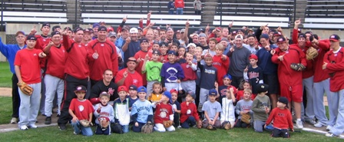
Directed by SCSU Head Coach, Pat Dolan, the 2015 and 2016 NCBWA Central Region Coach of the Year and 2016 National Coach of the Year and his staff!
Over 75 Central Minnesota players have played for SCSU since 2008!
R U NEXT?!
Location: Chaska Community Baseball Parks, Chaska, MN

Register On line at: www.StarzBaseballCamp.com
Or mail this form with payment to Starz of Tomorrow:
PO Box 2063, St. Cloud, MN 56302
Pat Dolan 320-333-3336

REGISTRATION Deadline May 25th, 2021
Registration: __$75 2nd Child in Family: __ $50
Skills Camps Features:
• Instruction on throwing, fielding, hitting, pitching, base running and more! Drillz &, Drillz to improve Baseball SKILLZ!
• Individual position practice, emphasis on skill development
• Lunch provided
- Camp T-shirt & participation award and Camper of the Day, Charlie. Hustle, Mr. Defense and MVP awards for each group
- Skill Testing in the 60 yard dash, home-to-1st base, position work, on field batting practice, radar gun speed and exit velo
- NEW!! Rapsodo providing base metrics for hitters and position players (spin rate, launch angle, exit velo, x & y axis for pitches, run value, etc.).

Registration Information:
Participant’s name: ______________________________________________________________

Position #1 ___ #2____Ht _____Wt ____Bat ___Throw __
Family Address _________________________________________City _____________ Zip ___
Daytime Phone _______________E-Mail (please print clearly!)_______________________________
Medical Information
Doctor__________________________________Phone_________________________________
Insurance coverage________________________________________________________
Statement of Release: I agree to release the Starz of Tomorrow Baseball Academy and all their employees of all liability related to accidents or injuries which may occur while participating in the above activity. I also give permission for emergency medical procedures to be administered if I cannot be contacted in case of an emergency.
Parent/Guardian signature __________________________________Date________________________________________________



