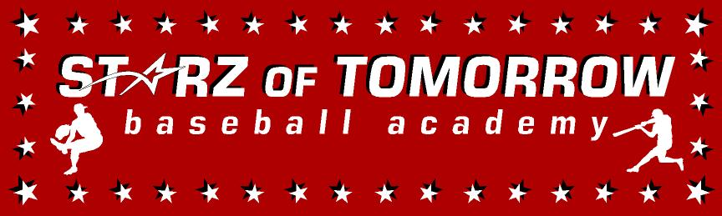
Sauk Rapids Mobile Baseball Summer Camp
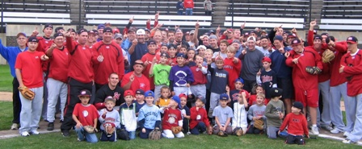

Who: Baseball Players ages 6-14, who is the next SR player like Mat Meyer coming to Huskyland?
What: An Instructional Baseball Camp
With the SCSU Husky Baseball Staff and players
When: Friday, June 14th
Time: 10:00am – 3:00pm with lunch provided
Where: Bob Cross Park, Sauk Rapids, MN
Cost: $35 Sauk Rapids Members/$50 non SR Members

For more information contact: Pat Dolan at 320-333-3336 www.StarzBaseballCamp.com

Come join us in some baseball fun and learn to play the game the right way!
BASEBALL DRILLZ, DRILLZ, DRILLZ to improve BASEBALL SKILLZ with the Starz!
Who is going to be the next Mat Meyer to Huskyland?

