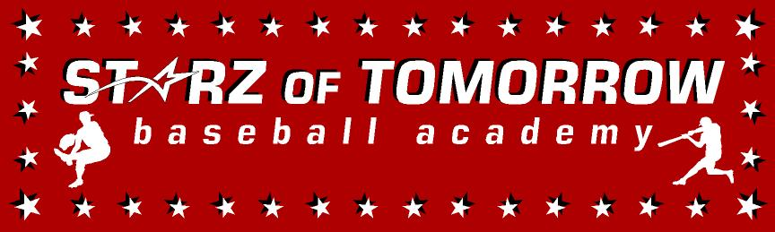
12th Husky Fall Developmental League-HFDL
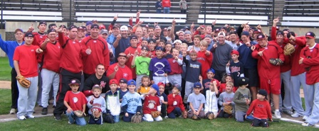

Who: Baseball Players ages 5-18
What: 12th Annual Fall Instructional/Developmental Baseball Clinics with the SCSU Baseball staff
When: Saturday, September 8 – Saturday, October 6
Time: 10:00am – 1:00pm
Where: Bob Cross Park in Sauk Rapids and other Central MN fields
Cost: $100 team rate, $125 for Early Bird Special 8-1-19
For more information contact: Pat Dolan at 320-333-3336 www.StarzBaseballCamp.com
Come join us in some baseball fun and learn to play the game the right way!
BASEBALL DRILLZ, DRILLZ, DRILLZ to improve BASEBALL SKILLZ with the Starz!
74 Central MN players have attended SCSU in the past 10 years with 6 playing professionally!
R U NEXT?!

