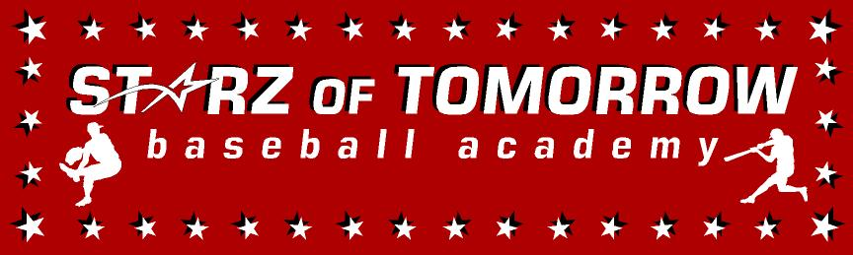

Starz of Tomorrow Baseball Academy
2017 MEA Skills Camp 8th Graders and Below
Thursday and/or Friday, October 19-20
Noon-4:00pm each day
Overnight campers ONLY charged $25.00 more for dinner & breakfast
Location Bob Cross Baseball Park, Sauk Rapids, MN
Or the SCSU Fieldhouse if bad weather

Register Online at: www.StarzBaseballCamp.com
Or mail this form with payment to Starz of Tomorrow:
PO Box 2063, St. Cloud, MN 56302
For More Information contact Clinic Director:
Pat Dolan @: Pat@StarzBaseballCamp.com

REGISTRATION Deadline October 10th, 2017
One Day Camp ($50.00)
* Instruction on throwing , fielding and hitting fundamentals
* Individual position practice, emphasis on skill development
* Lunch provided
* Starz of Tomorrow camp certificate
* Optional early drop off at 8:00am and pick up at 4:00pm for $5 per hour with baseball movies and snacks provided!

Two Day Camp: ($75.00)
- Day 2 camp will be more advanced and defensive position specific instruction and drills and advanced offensive training
- Skill Testing in the 60 yard dash, home-to-1st base, position work, on field batting practice, radar gun speed
- Starz of Tomorrow camp t-shirt and camp certificate
- Lunch provided

Overnight Camp ($100.00)
- Team Dinner and morning team breakfast provided
- Transportation provided
- Baseball fun night with “baseball chalk talk” and baseball movies!
- Supervised staff will be staying with the overnight campers with an 11:00pm room check and 11:30 lights out

Registration Information:
Participant’s name: ________________________ School ________________________Grade___
October 19 or 20 ($50)_________Both days ($75) ________Overnight camp ($100) _________
Roommate preference? _________________ __________________ ___________________
Family Address _________________________________________City _____________ Zip ___
Daytime Phone _______________E-Mail (please print clearly!)_______________________________
Medical Information
Doctor__________________________________Phone_________________________________
Insurance coverage________________________________________________________
Statement of Release: I agree to release the Starz of Tomorrow Baseball Academy and all their employees of all liability related to accidents or injuries which may occur while participating in the above activity. I also give permission for emergency medical procedures to be administered if I cannot be contacted in case of an emergency.
Parent/Guardian signature __________________________________Date________________________________________________

