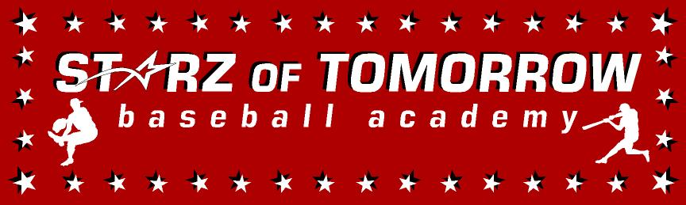

Starz of Tomorrow Baseball Academy
2017 Dassel Summer Skills Camp
Friday, June 9 10:00-4:30pm
10:00am-3:30 Skills Camp & GAME from 3:30-4:30pm!
Dinner and stay for the Saints game after the camp!

Directed by SCSU Head Coach, Pat Dolan, the 2015 and 2016 NCBWA Central Region Coach of the Year and 2016 National Coach of the Year and his staff!
Location: Dassel Baseball Field

Register On line at: www.StarzBaseballCamp.com
Or mail this form with payment to Starz of Tomorrow:
PO Box 2063, St. Cloud, MN 56302
For More Information contact Clinic Director:

Pat Dolan @: Pat@StarzBaseballCamp.com

REGISTRATION Deadline June 1, 2017
REGISTRATIN FEE $50.00
Skills Camps Features:
• Instruction on throwing, fielding, hitting, pitching, base running and more! Drills Drills, Drills to improve SKILLS!
• Individual position practice, emphasis on skill development
• Lunch provided
- Camp T-shirt and participation award
- Skill Testing in the 60 yard dash, home-to-1st base, position work, on field batting practice, radar gun speed

Registration Information:
Participant’s name: ______________________________________________________________

Position #1 ___ #2____Ht _____Wt ____Bat ___Throw __
Family Address _________________________________________City _____________ Zip ___
Daytime Phone _______________E-Mail (please print clearly!)_______________________________
Medical Information
Doctor__________________________________Phone_________________________________
Insurance coverage________________________________________________________
Statement of Release: I agree to release the Starz of Tomorrow Baseball Academy and all their employees of all liability related to accidents or injuries which may occur while participating in the above activity. I also give permission for emergency medical procedures to be administered if I cannot be contacted in case of an emergency.
Parent/Guardian signature __________________________________Date________________________________________________

