
Stearns County Baseball Summer Camp
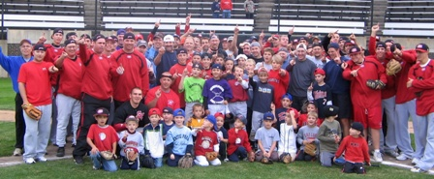

Who: Baseball Players ages 5-14
What: An Instructional Baseball Camp
With the SCSU Husky Baseball Staff and players
When: Friday, July 15th, 2016
Time: 10:00am – 5:00pm
Where: Elrosa Baseball Complex
Cost: $50.00 for the camp, camp t-shirt and handouts!
Lunch provided
$30.00 only for Elrosa players and all BBE players
For more information contact: Pat Dolan at 320-333-3336 Pat@StarzBaseballCamp.com

Come join us in some baseball fun and learn to play the game the right way!

