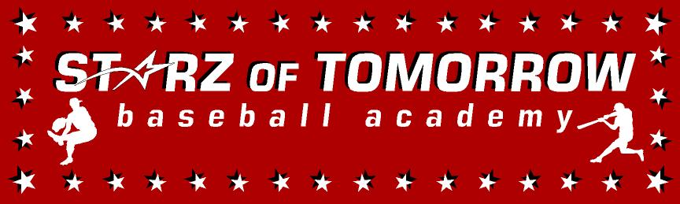


Starz of Tomorrow Baseball Academy
What’s NEW?

- Rapsodo Hitting/Pitching- State-of-the-art development software that allows us to put a measurement and gauge where, how, and why your athlete is hitting and pitching the way that they are! Young campers will have the opportunity to use our software to gather base metrics (spin rate, launch angle, exit velocity, bat speed, spin efficiency, etc.). This will be utilized weekly to see just how our young campers our progressing throughout our Fall League duration. KNOW THAT YOUR YOUNG PLAYER IS DEVELOPING INTO A BETTER PLAYER! NO MORE ASSUMPTIONS!

- Videotape analysis on hitting and pitching offered!

- “Go About Your Business Like A Professional; LIKE A HUSKY!” Begin each session with a Dynamic Body Warm just like the SCSU Huskies to ensure your body and arm are ready to compete and HAVE FUN at their highest potential.

- Introduction to J-Band & PlyoCare Arm Care Routine- Teach the players to instill an arm care routine to their everyday warm-up regiment to ensure our campers are healthy and strong enough to compete at their highest level. WARM-UP TO PLAY CATCH! NOT PLAY CATCH TO WARM-UP! Just like a Husky!

- Pro-Agility Training: position specific plyometric exercises to ensure athletes are strong, but most importantly moving efficiently on the field. Timed Shuttle Sprints, Dynamic Cone Acceleration Drills. No long-distance; baseball is a sport of explosion and speed!

- YOU ARE WHAT YOU EAT: Mini-presentations on proper athletic nutrition to fuel your body to perform at its most optimal level.

- “BE A GYM RAT.” Presentations regarding how Weight-Training/Strength & Conditioning is a crucial foundation for young athletes who intend to play baseball at the collegiate level. And starter programs for the young player with body awareness and body weight training!

