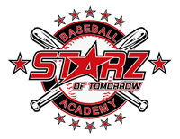

Starz of Tomorrow Off-Season/Spring Training Camp

Off-Season Training & Dynamic Workouts to get you ready for your upcoming Spring Season!

- Daily Dynamic Body Mobility & Plyometric Warm-Ups
  - Foam-Roll Activation
  - Youth J-Band Series Arm Care
  - Youth Introduction to Driveline Baseball Plyocare Ball Drills
    - Reverse Throws
    - Pivot Pick-Offs
    - Roll-In Throw
    - Rocker Throw
- Personalized Throwing Programs with Workouts for duration of camp
  - Youth Introduction to Driveline Baseball Arm-Care Recovery
- Rudimentary Entry-Level Weight Room Workouts and Static Stretching with Coach Gaines and SCSU Baseball S&C Coach, Nate Welty
  - Banded Stretch Routine
  - Pool Workouts
  - Speed and Agility Drills

