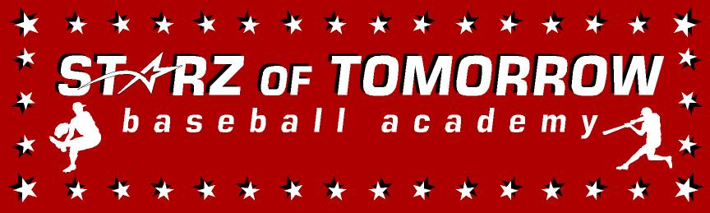

Starz of Tomorrow Baseball Coaching Book Series

A series of 9 e-mail baseball books and game charts that covers pretty much EVERYTHING you could imagine about this great game of baseball! It starts from basic things like how to hold a bat and baseball to more advanced items liking defending the 1st and 3rd steal (and that’s an issue at all levels, not just youth levels!), pitcher/catcher signal communication, pitching, hitting, base running, bunting philosophies and much more!

There are well over 200 baseball drills on every aspect of the game. The entire series is well over 400 pages of great baseball information

The series covers the following topics:
- Base Running
- Bunting
- Catching
- Hitting
- Infield Play
- Outfield Play
- Pitching
- Team Defense
- Team Offense
- Game Charts

Each book is $9.99 and then entire book can be purchased for $49.00.

Order online at www.StarzBaseballCamp.com or call 320-333-3336 or send check to: Starz of Tomorrow, PO Box 2063, St. Cloud, MN 56304
And include this form!

